Using Classifier Models to Predict Solar Panel Efficiency After Extreme Weather Events
Samuel Zhang, Paul Yoo

Notes:
- Introduction/data -> talk about is it balanced? Imbalanced? And show the graph, we already have that
- Preprocessing
- Attribute Selection
  - Screenshots
  - Needs to be noted that
- Classification Models
  - Performance metrics
  - Confusion matrix analysis
  - Area under curve metrics(ROC AUC), ROC AUC is used when classes are balanced: otherwise, use PCR
- Results/Discussion
  - Have a huge table where each row represents attribute selection algorithm and
  - Show the best model’s and top 2’s and bottom 2’s confusion matrices
  - On presentation, do not just report: This attribute selection and this algorithm ddi best… show the whole picture of the other algorithm and attribute selections

Motivated by the increased development of renewable energy sources, notably solar power, we investigate how extreme weather conditions can impact solar power plant performance. The dataset we used combined three distinct datasets (operations and maintenance tickets, weather data, and production data) to investigate the effect of certain weather conditions into one large combined dataset. We contribute to this investigation by training a machine learning classifier model to predict a discretized “efficiency” category (PR, “low”, “medium”, “high”) of solar power plants after extreme weather events. The dataset for this project [1] is obtained from the paper “Evaluation of extreme weather impacts on utility-scale photovoltaic plant performance in the United States” by Nicole D. Jackson and Thushara Gunda [2].

The data has 51504 instances where each instance represents a solar power plant on a certain day. The dataset’s 37 attributes describe climatic conditions including temperature and information about the most recent occurrences of hazards/storms such as hurricanes and lightning. Figure 1 displays the definitions of each attribute and the class variable PR(performance ratio):

Variable | Description
randid | Performance day formatted as MM/DD/YYYYY
Date | Performance day, formated as month/day/year
NOAAClimRegion | climate region that the site's state falls within: https://www.ncdc.noaa.gov/monitoring-references/maps/us-climate-regions.php
TempZone | Thermal zone extracted from the PV Climate zones based on Karin et al (2019) package
HumidZone | Humidity zone extracted from the PV Climate zones based on Karin et al (2019) package
bin_PlantSize_kW | DC nameplate power, Categories: small, medium, large
plant_age_months | Number of months since commissioning
active_snow_tickets | Total number of active tickets relating to snow events
snow_bin_ticket_minutes | Portion of performance day occupied by snow O&M tickets. Categories Partial, Majority, Full, None
snow_affected_assets | Type of asset affected as identified by snow-related O&M tickets
snow_production_level | Estimated production impacted based on snow-related O&M tickets. Categories: Full, Partial, Unknown, N/A
PR | Performance ratio as defined by IEC 61724
snow_value_mm | Total daily snowfall at the site based on GHCN data in millimeters
total_daily_snow_mm | Total daily snowfall at the site based on GHCN data in millimeters
low_irradiation | Binary indicator if Irradiance is categorized as "low"
cumulative_snow_mm | Cumulative total snowfall since the start of the available production data
hurr_bin_ticket_minutes | Portion of performance day occupied by hurricane O&M tickets. Categories Partial, Majority, Full, None
hurr_affected_assets | Type of asset affected as identified by hurricane-related O&M tickets
hurr_production_level | Estimated production impacted based on hurricane-related O&M tickets. Categories: Full, Partial, Unknown, N/A
HurricanePrep | Indicator if inspection too place prior to hurricane event according to O&M tickets
HurricanePostInspection | Indicator if inspection too place after to hurricane event according to O&M tickets
hurricane | Indicator if there is a hurricane on the given day
nearest_hurricane | Number of days since last recorded hurricane event.  If no events were recorded, the last recorded event  is set to the site's commissioning day.
wind_speed_mean | Average daily wind speed at site.  Categories: low, medium, high
rain_value_mm | Total daily rainfall at the site based on PRISM.
nearest_rain | Number of days since last recorded rainfall.  If no events were recorded, the last recorded event  is set to the site's commissioning da
active_storm_tickets | Total number of active tickets relating to storm events
storm_bin_ticket_minutes | Portion of performance day occupied by storm O&M tickets. Categories Partial, Majority, Full, None
storm_affected_assets | Type of asset affected as identified by storm-related O&M tickets
storm_production_level | Estimated production impacted based on storm-related O&M tickets. Categories: Full, Partial, Unknown, N/A
lightning | Indicator if there is a lightning on the given day according to storm-related O&M tickets
storm | Indicator if there is a storm on the given day
duration_minutes_storm | Total minutes across all storm events at a site for the given day
nearest_storm | Number of days since last recorded storm event.  If no events were recorded, the last recorded event  is set to the site's commissioning day.
flood | Indicator if there is a flood on the given day
duration_minutes_flood | Total minutes across all flood events at a site for the given day
nearest_flood | Number of days since last recorded flood.  If no events were recorded, the last recorded event  is set to the site's commissioning da
rain | Indicator if there is a rain on the given day
Table 1: The data dictionary where the terms of each attribute is defined on the right column and the highlighted row is the class variable[1]

Data Preprocessing
The full extent of data preprocessing goes as follows:
- We addressed missing or possibly erroneous PR values across instances. There were 1,564 instances missing the class variable PR and another 6,343 had a PR of 0, which we treated as a recording error. After these instances were dropped, we were left with 43,597 instances.
- Since the PR class variable is continuous, it was discretized into three categories. The categories representing low, medium, and high efficiency had a PR below 0.7, from 0.7 to 0.8 (inclusive), and above 0.8, respectively. It should be noted that the classes are not completely balanced: 10,100 instances (23.2%) are low, 20,057 (46.0%) are medium, and 13,440 (30.8%) are high, as shown in Figure 1. These thresholds are easily interpretable and result in reasonable class variable distribution.

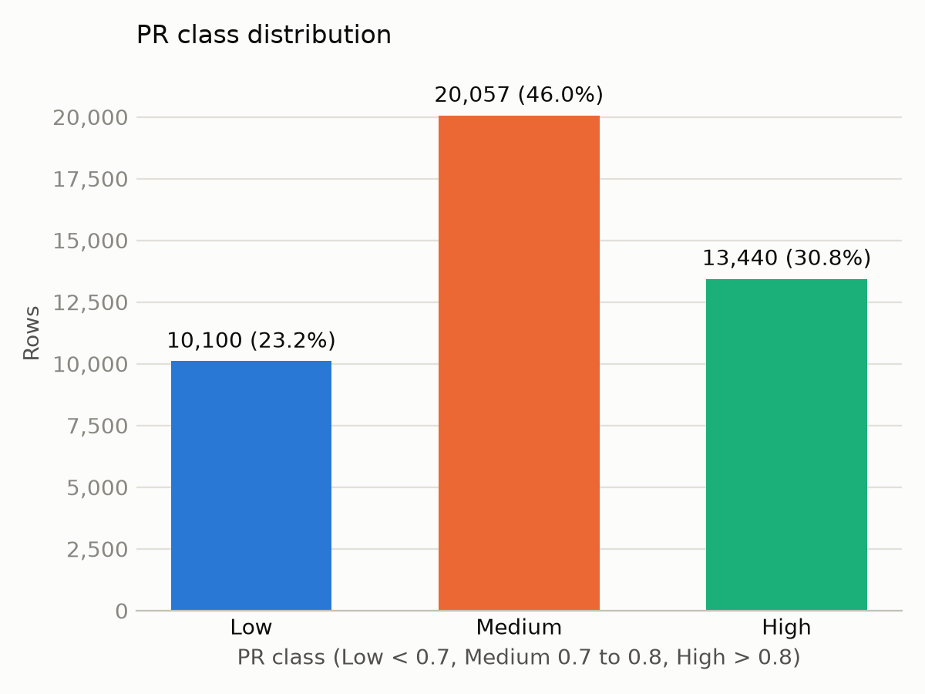

Figure 1: Bar Graph displaying the distribution for class
- There were several attributes missing significant amounts of instances to record them. To prevent sparsity, we removed the following attributes: storm_affected_assets(99.6% missing), storm_bin_ticket_minutes(99.6% missing), hurr_affected_assets(99.3% missing), hurr_bin_ticket_minutes(99.3% missing), snow_affected_assets(98.8% missing), and snow_bin_ticket_minutes(98.8% missing).
- We also removed the rain attribute, since it is trivially equivalent to checking if rain_value_mm > 0. Date was also removed and replaced with season and month, as it would likely lead to extreme sparsity among attributes whose dates can be spread around 365 days instead of only 4 seasons or 12 months. Moreover, randid was removed, since we considered it unhelpful for the model to simply learn specific patterns for each solar panel site - the model should be helpful in predicting PR for new sites as well instead of memorizing the behavior of each site.
- We then went to handle outliers. The primary issue for outliers was the wind_speed_mean attribute. Even though the lowest 99% of instances have values before 10, there were large extremities towards the high end of wind_speed_mean. For example, the maximum recorded wind speed was 2672. 66 instances had wind_speed_mean > 100, and more. To prevent outliers and make future normalization easier, we removed all 128 features with wind_speed_mean as a reasonable cutoff to bound wind_speed_mean, Overall, 128 features were removed due to the wind_speed_mean analysis.
- The data was then converted from the unclear oedi_data.xlsx and comes back with somewhat cleaned pre-processing data which is then split into train.csv and test.csv using stratified random sampling, an 80/20 ratio, and seed 42. This demonstrates how the raw unfiltered data was converted to train/test split csv’s.
- The next step performed was data imputation. Mode was used on all nominal attributes, which included binary state columns and generally most text-based value columns. Mean was used to impute on all the quantitative, numeric attributes as well.
- Then, all numeric features were normalized to prevent scale distortion. Numeric features were normalized using z-score using StandardScalar
After all these data preparation steps, train.csv and test.csv contain data ready for attribute selection.

Attribute Selection:
The following attribute selection algorithms were used to generate different train and test sets:

Gain Ratio Attribute Evaluator
The Gain Ratio attribute evaluator is a feature selection method that measures the value of an attribute by normalizing its information gain using its intrinsic information.

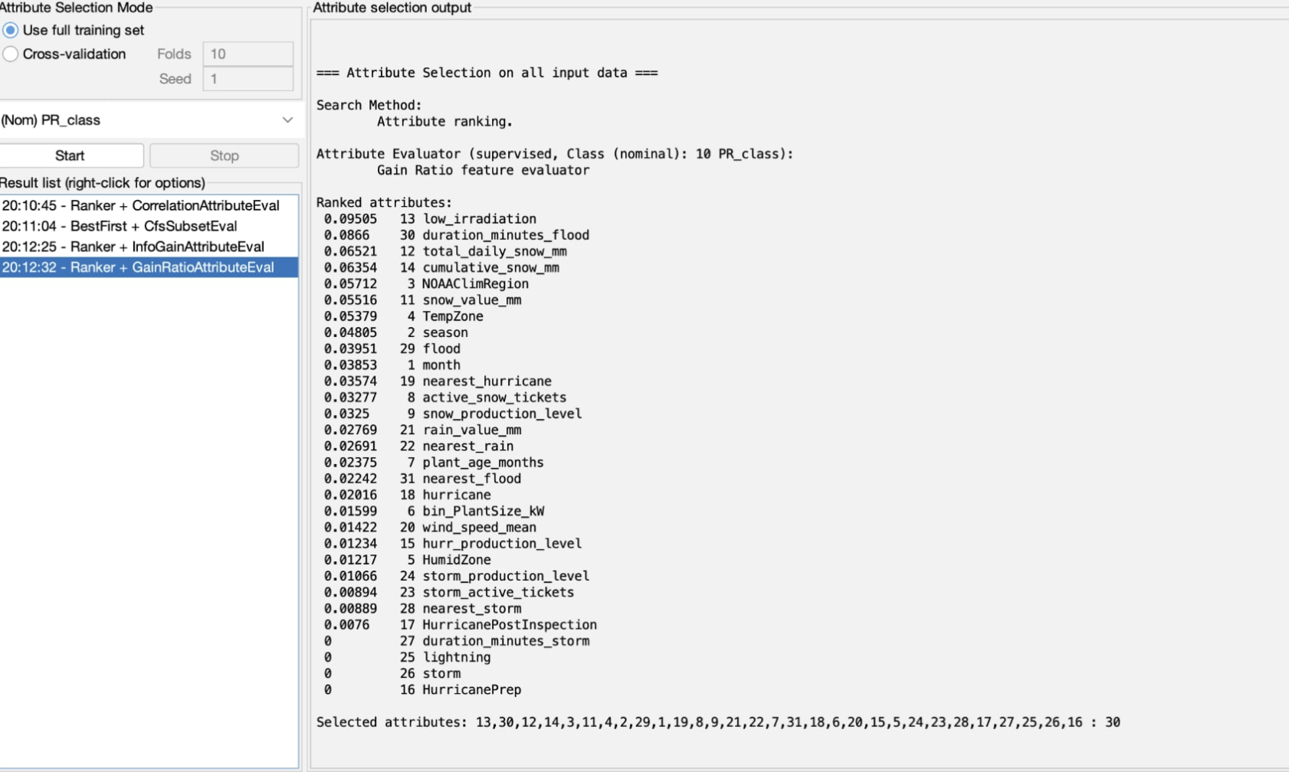
Figure 2:

Correlation-based feature selection (CFS)
Correlation-based Feature Selection (CFS) Subset Evaluation is a feature selection method in machine learning that evaluates the value of a subset of features rather than each individual attribute.

Information Gain Attribute Evaluator
The Information Gain Attribute Evaluator is a feature selection algorithm that measures the value of each attribute by information gain relative to the target class.

- Correlation Attribute Evaluator
The Correlation Attribute Evaluator is a feature selection algorithm that evaluates attribute value by calculating the Pearson correlation coefficient with respect to the target class. If the target class is nominal(like in this case), Correlation Attribute Evaluator treats each class value as a binary indicator(1 if an instance has this specific class value, 0 otherwise) and does a weighted average of correlation.

Manual Selection of Certain Attributes
We selected 12 attributes that we thought should affect a solar plant's PR: climate, plant size and age, time of year, and weather conditions such as irradiation, snow, rain and wind. This selection was made before seeing any model results and was based off reasonably important attributes.

Selection Algorithm | Settings
CfsSubsetEval | Evaluator: weka.attributeSelection.CfsSubsetEval -P 1 -E 1  Search: weka.attributeSelection.BestFirst -D 1 -N 5
GainRatioAttributeEval | Evaluator: weka.attributeSelection.GainRatioAttributeEval  Search: weka.attributeSelection.Ranker -T -1.7976931348623157E308 -N -1
InfoGainAttributeEval | Evaluator: weka.attributeSelection.InfoGainAttributeEval  Search: weka.attributeSelection.Ranker -T -1.7976931348623157E308 -N -1
CorrelationAttributeEval | Evaluator: weka.attributeSelection.CorrelationAttributeEval  Search: weka.attributeSelection.Ranker -T -1.7976931348623157E308 -N -1
Table 2. Settings for feature selection algorithms. Each of the Weka selection algorithm settings are detailed above.
# | CFS (8) | InfoGain (10) | GainRatio (10) | Correlation (10) | Manual (12)
1 | month | NOAAClimRegion | low_irradiation | low_irradiation | NOAAClimRegion
2 | season | month | duration_minutes_flood | NOAAClimRegion | TempZone
3 | NOAAClimRegion | cumulative_snow_mm | total_daily_snow_mm | total_daily_snow_mm | HumidZone
4 | TempZone | plant_age_months | cumulative_snow_mm | TempZone | bin_PlantSize_kW
5 | total_daily_snow_mm | season | NOAAClimRegion | season | plant_age_months
6 | low_irradiation | TempZone | snow_value_mm | cumulative_snow_mm | month
7 | cumulative_snow_mm | nearest_rain | TempZone | snow_value_mm | low_irradiation
8 | nearest_rain | low_irradiation | season | month | total_daily_snow_mm
9 |  | total_daily_snow_mm | flood | wind_speed_mean | cumulative_snow_mm
10 |  | nearest_flood | month | plant_age_months | rain_value_mm
11 |  |  |  |  | nearest_rain
12 |  |  |  |  | wind_speed_mean
Table 3. Selected attributes across feature selection algorithms. Each column lists one of the attribute selection algorithms, the count of the number of new attributes, and the exact attributes selected.

Attribute | CFS | InfoGain | GainRatio | Correlation | Manual | Sets
month | ✓ | ✓ | ✓ | ✓ | ✓ | 5
NOAAClimRegion | ✓ | ✓ | ✓ | ✓ | ✓ | 5
TempZone | ✓ | ✓ | ✓ | ✓ | ✓ | 5
total_daily_snow_mm | ✓ | ✓ | ✓ | ✓ | ✓ | 5
low_irradiation | ✓ | ✓ | ✓ | ✓ | ✓ | 5
cumulative_snow_mm | ✓ | ✓ | ✓ | ✓ | ✓ | 5
season | ✓ | ✓ | ✓ | ✓ |  | 4
plant_age_months |  | ✓ |  | ✓ | ✓ | 3
nearest_rain | ✓ | ✓ |  |  | ✓ | 3
snow_value_mm |  |  | ✓ | ✓ |  | 2
wind_speed_mean |  |  |  | ✓ | ✓ | 2
HumidZone |  |  |  |  | ✓ | 1
bin_PlantSize_kW |  |  |  |  | ✓ | 1
rain_value_mm |  |  |  |  | ✓ | 1
flood |  |  | ✓ |  |  | 1
duration_minutes_flood |  |  | ✓ |  |  | 1
nearest_flood |  | ✓ |  |  |  | 1
active_snow_tickets |  |  |  |  |  | 0
snow_production_level |  |  |  |  |  | 0
hurr_production_level |  |  |  |  |  | 0
HurricanePrep |  |  |  |  |  | 0
HurricanePostInspection |  |  |  |  |  | 0
hurricane |  |  |  |  |  | 0
nearest_hurricane |  |  |  |  |  | 0
storm_active_tickets |  |  |  |  |  | 0
storm_production_level |  |  |  |  |  | 0
lightning |  |  |  |  |  | 0
storm |  |  |  |  |  | 0
duration_minutes_storm |  |  |  |  |  | 0
nearest_storm |  |  |  |  |  | 0
Table 4. Attribute sets that include each attribute. Sets = number of the five attribute selection algorithms that chose the attribute.

Training

Naive Bayes
Naive Bayes is a classifier that computes probability values for each class label (in this case, low, medium, and high), and predicts the class with the highest probability. One weakness is that it treats each attribute independently by generating probability values

J48
J48 constructs a tree that splits data by the attributes that separates class labels(low, medium, high) by info gain ratio. Each branch adds an additional constraint, and a leaf in the tree is a final label. A weakness is that the J48 tree may overfit too heavily by creating too many branches, and tree pruning is used to reduce this.

Random Forest
Random Forest consists of many decision trees which are trained across different samples and subsets of attributes. Every individual tree in the forest predicts a class label and the final classifier picks the most commonly predicted label. This can significantly reduce overfitting compared to the single decision tree, but is also a more complicated model that requires more time and memory.

JRip
JRip is a classifier that builds a set of if-then statements. JRip starts from the least common class labels to the most common ones, and tries to determine if an instance fits the current rules before moving onto the next, more prevalent class label. One issue is that JRip applies all these rules in a fixed order, so it can miss out on more complicated relationships that would have led to an instance being classified as a more common label.

Results

References
[1] https://data.openei.org/submissions/4055
[2] https://www.sciencedirect.com/science/article/pii/S0306261921008898?via%3Dihub#appSB

